**TITLE OF LAB: (SERIES AND PARALLEL CLIPPERS)**

**Lab No. #05**



**Spring 2022**

**CSE-206L Electronic Circuits Lab**

Submitted by

**Safi Ullah Khan : 20PWCSE1943**

Class Section: **B**

“On my honor, as student of University of Engineering and Technology, I have neither given nor received unauthorized assistance on this academic work.”

Student Signature: ______________

Submitted to:

**Engr. Abdullah Hamid**

(Monday, June 19th, 2022)

**Department of Computer Systems Engineering**

**University of Engineering and Technology, Peshawar**

**Objectives:**

* To understand different types of clipping circuits.
* To view waveforms of different clippers.

**Equipment’s:**

* Oscilloscope
* Digital Multimeter (DMM)
* DC Power Supply

**Components:**

* Diode Silicon (D1N4002)
* Resistor of 1k or 2.2k

**Theory about clippers:**

Definition: Clipper circuits are the circuits that clip off or removes a portion of an input signal, without causing any distortion to the remaining part of the waveform. These are also known as clippers, clipping circuits, limiters, slicers etc.

Clippers are basically wave shaping circuits that control the shape of an output waveform. It consists of linear and non-linear elements but does not contain energy storing elements.

**Where it uses clippers?**

Clipper circuits are basically termed as protection devices. As electronic devices are voltage sensitive and voltage of large amplitude can permanently destroy the device. So, in order to protect the device clipper circuits are used.

If there is input voltage more than required voltage, than we can use clipper circuit to reduce it to required voltage.

1. **Series Clippers**
   1. **Negative Series Clippers**

Below is schematic for negative series clippers.

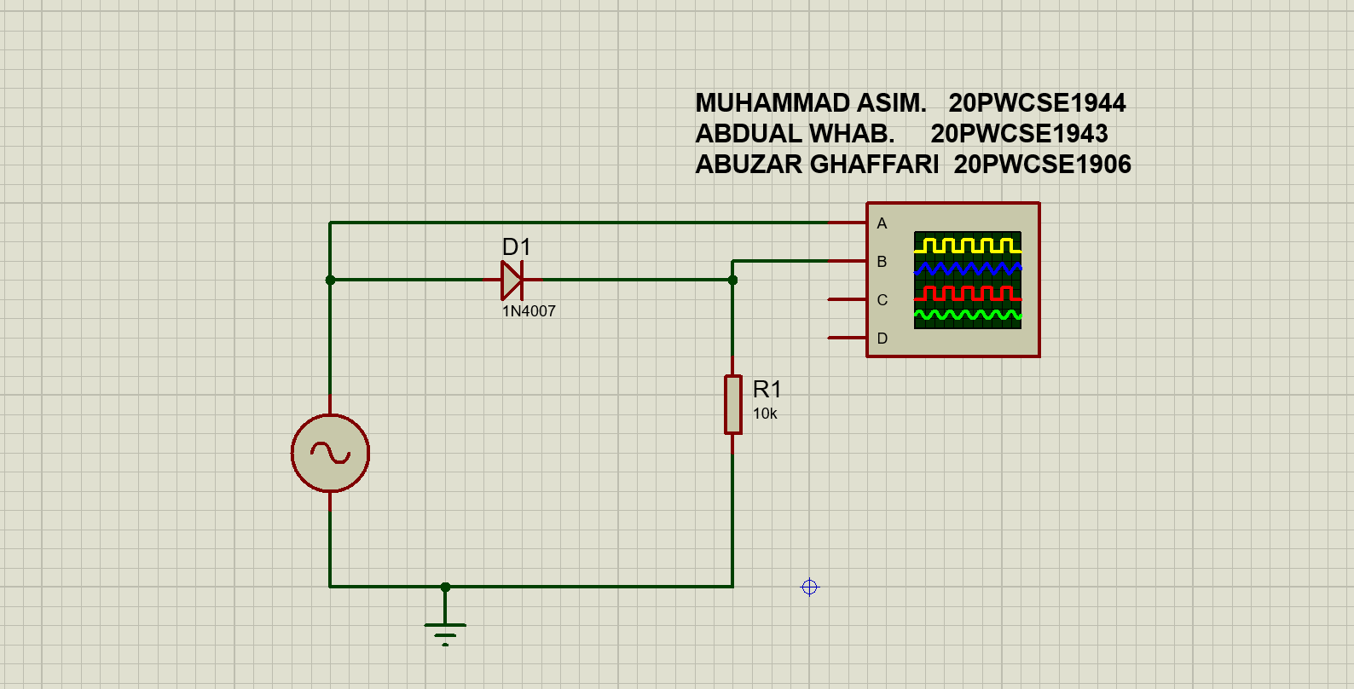

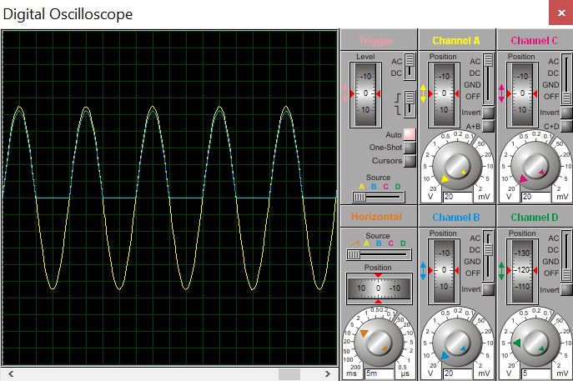The output is given bellow.

|  |  |  |  |  |  |  |  |
| --- | --- | --- | --- | --- | --- | --- | --- |
| V/Div | Channel A  20.00 V |  | Channel B  20.00 V |  | Channel C  20.00 V |  | Channel D  5.00 V |
| Offset Invert Coupling | 0.00 V Normal AC |  | 0.00 V Normal DC |  | 0.00 V Normal Off |  | -60.00 V  Normal Off |
|  | Horizontal |  |  |  | Trigger |  |  |
| Source | Trace |  |  | Source | Channel A |  |  |
| Position | 0.00 S |  |  | Level | 0.00 V |  |  |
| S/Div | 5.00 mS |  |  | Coupling | AC |  |  |

* 1. **Positive series clipper:**

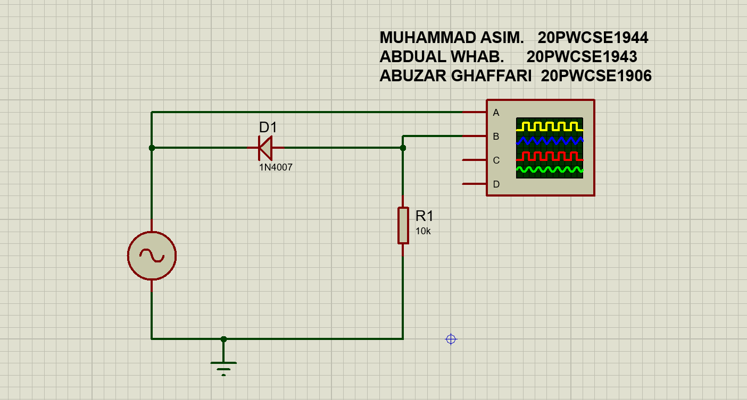

Output is given below:

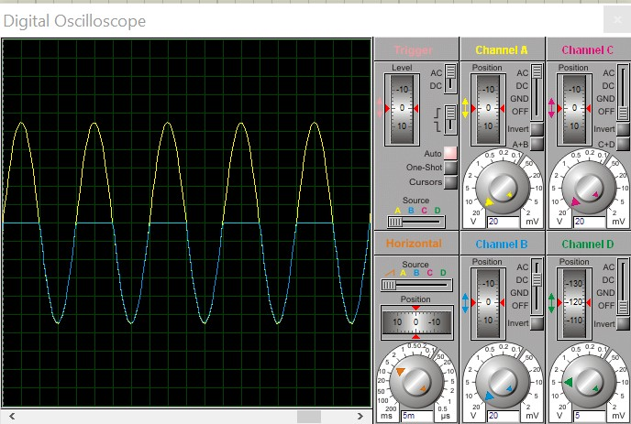

I have provided pdf print of oscilloscope output bellow.

|  |  |  |  |  |  |  |  |
| --- | --- | --- | --- | --- | --- | --- | --- |
| V/Div | Channel A  20.00 V |  | Channel B  20.00 V |  | Channel C  20.00 V |  | Channel D  5.00 V |
| Offset Invert Coupling | 0.00 V Normal AC |  | 0.00 V Normal DC |  | 0.00 V Normal Off |  | -60.00 V  Normal Off |
|  | Horizontal |  |  |  | Trigger |  |  |
| Source | Trace |  |  | Source | Channel A |  |  |
| Position | 0.00 S |  |  | Level | 0.00 V |  |  |
| S/Div | 5.00 mS |  |  | Coupling | AC |  |  |

# Parallel Clippers

## **2.1) Parallel negative clippers**

Below are both schematics and oscilloscope output.

# 

## 

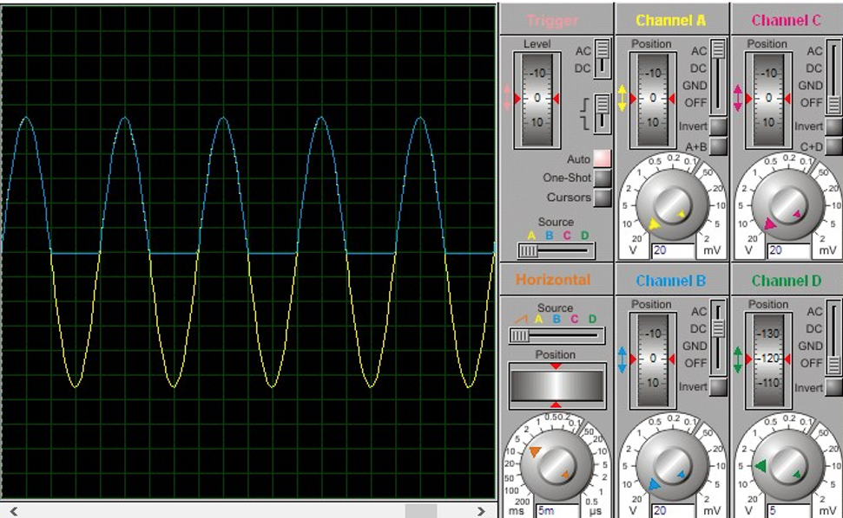

Since its output is same as that of negative series clipper, I did not take its pdf print.

## **Parallel Positive clipper**

schematics and oscilloscope are given below:

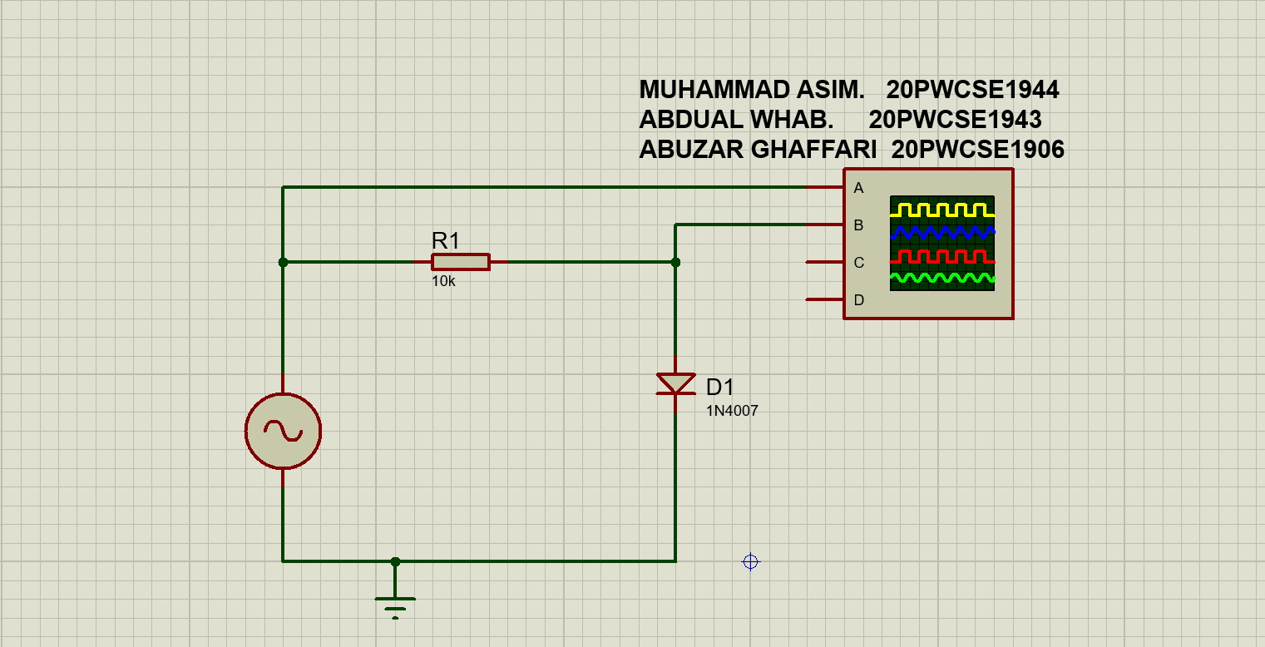

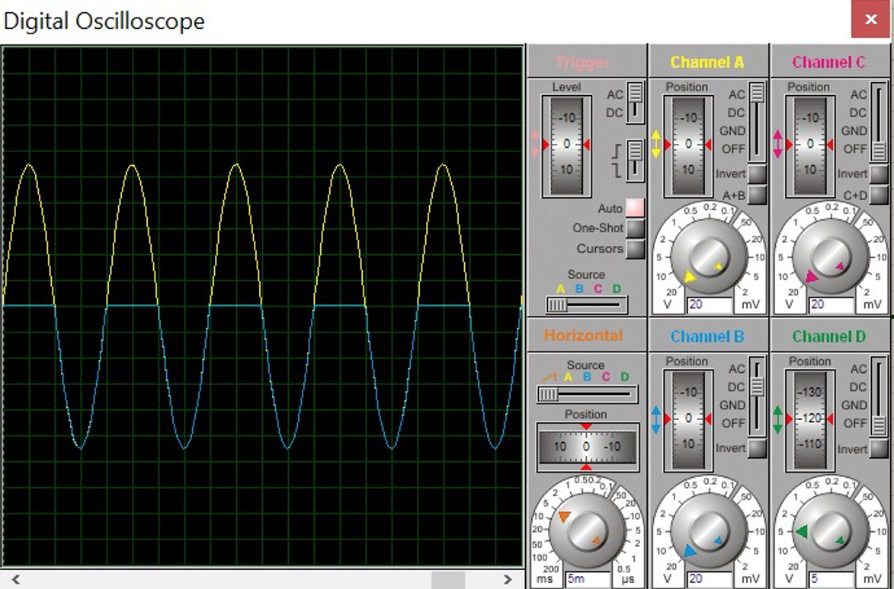

Again, since its output is same as positive series clipper, I did not take its pdf print.

# Biased Circuit

# 3.1) Series positive biased (+60V).

Schematics is given below:

# 

While oscilloscope output is as follows:

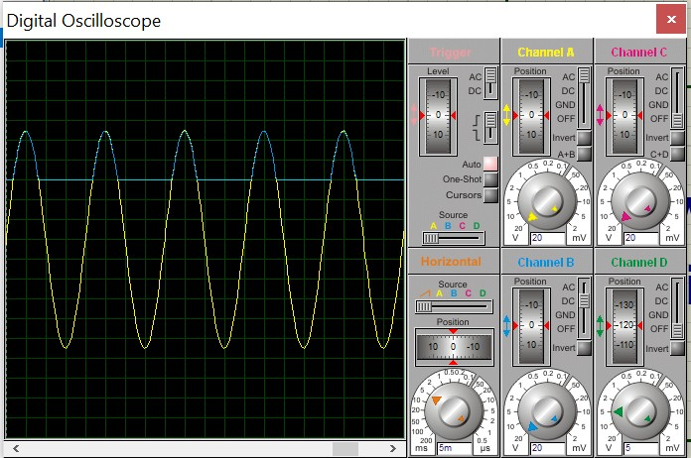

A pdf print of this output is given on next page.

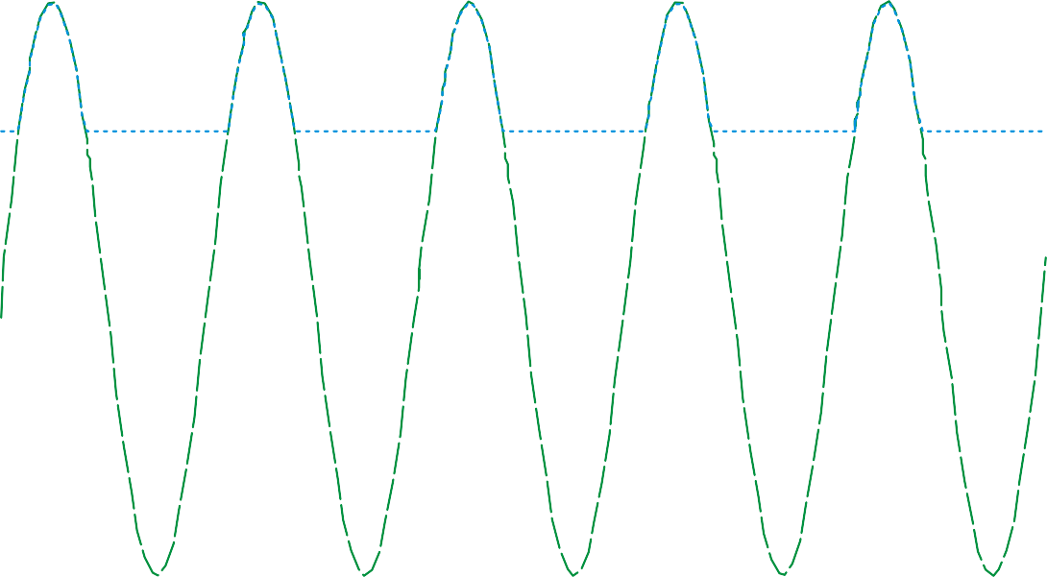

|  |  |  |  |  |  |  |  |
| --- | --- | --- | --- | --- | --- | --- | --- |
| V/Div | Channel A  20.00 V |  | Channel B  20.00 V |  | Channel C  20.00 V |  | Channel D  5.00 V |
| Offset Invert Coupling | 0.00 V Normal AC |  | 0.00 V Normal DC |  | 0.00 V Normal Off |  | -60.00 V  Normal Off |
|  | Horizontal |  |  |  | Trigger |  |  |
| Source | Trace |  |  | Source | Channel A |  |  |
| Position | 0.00 S |  |  | Level | 0.00 V |  |  |
| S/Div | 5.00 mS |  |  | Coupling | AC |  |  |

## **3.2) Parallel Dual biased (+60 and -40V)**

My favorite biased circuit is the parallel dual biased in which we can add bias in both +ve and –ve region. Schematic is given bellow,

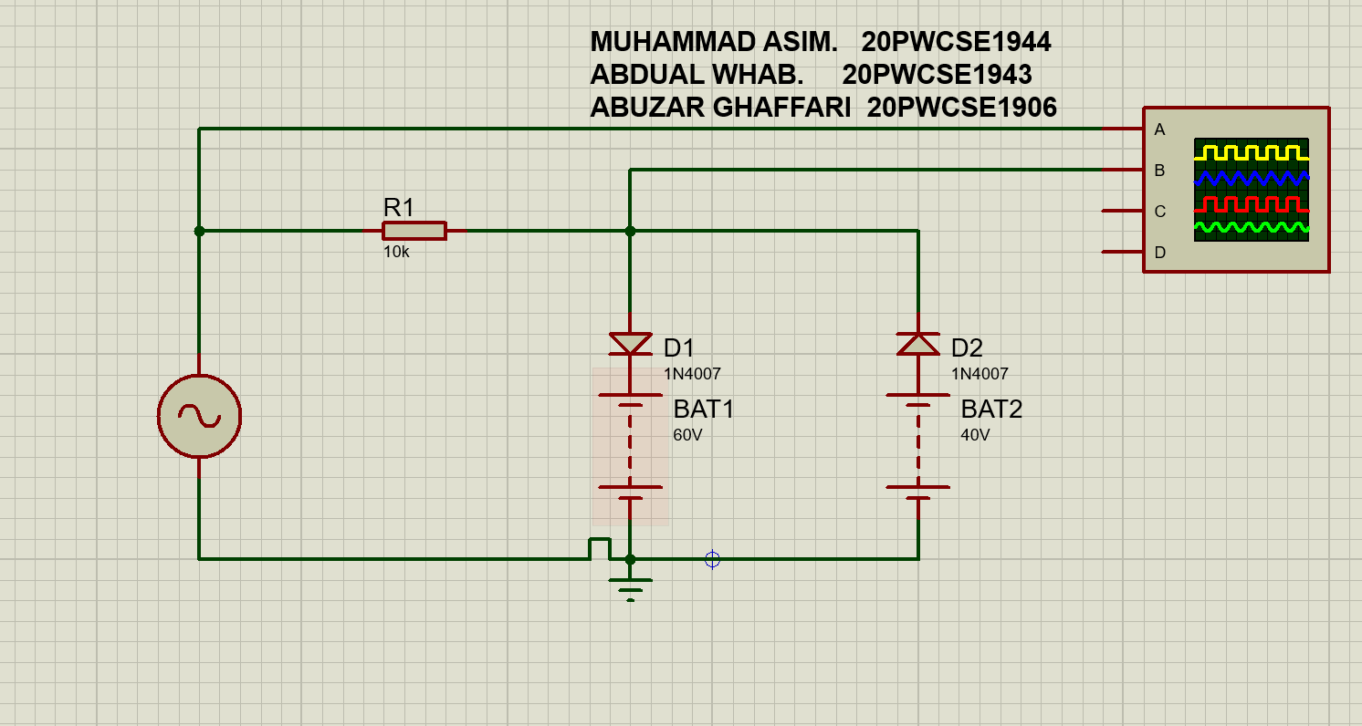

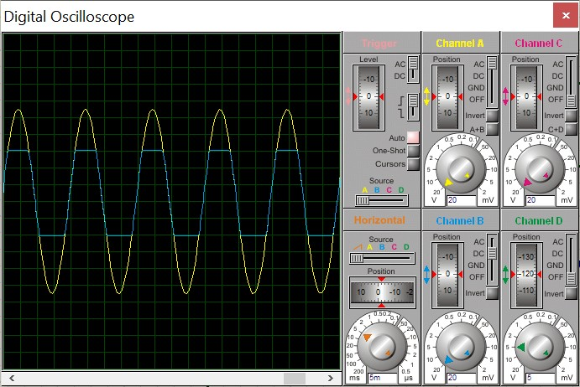

The oscilloscope output is as follows:

A pdf print is given on next page.

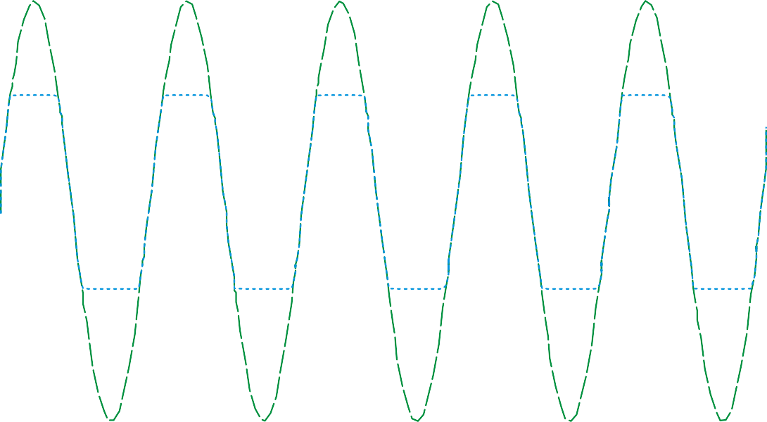

|  |  |  |  |  |  |  |  |
| --- | --- | --- | --- | --- | --- | --- | --- |
| V/Div | Channel A  20.00 V |  | Channel B  20.00 V |  | Channel C  20.00 V |  | Channel D  5.00 V |
| Offset Invert Coupling | 0.00 V Normal AC |  | 0.00 V Normal DC |  | 0.00 V Normal Off |  | -60.00 V  Normal Off |
|  | Horizontal |  |  |  | Trigger |  |  |
| Source | Trace |  |  | Source | Channel A |  |  |
| Position | -500.00 uS |  |  | Level | 0.00 V |  |  |
| S/Div | 5.00 mS |  |  | Coupling | AC |  |  |

**Positive clippers:**

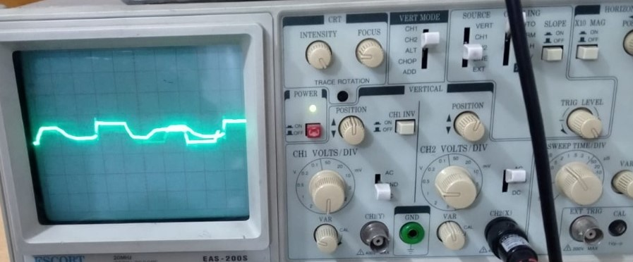

**Negative Clippers:**

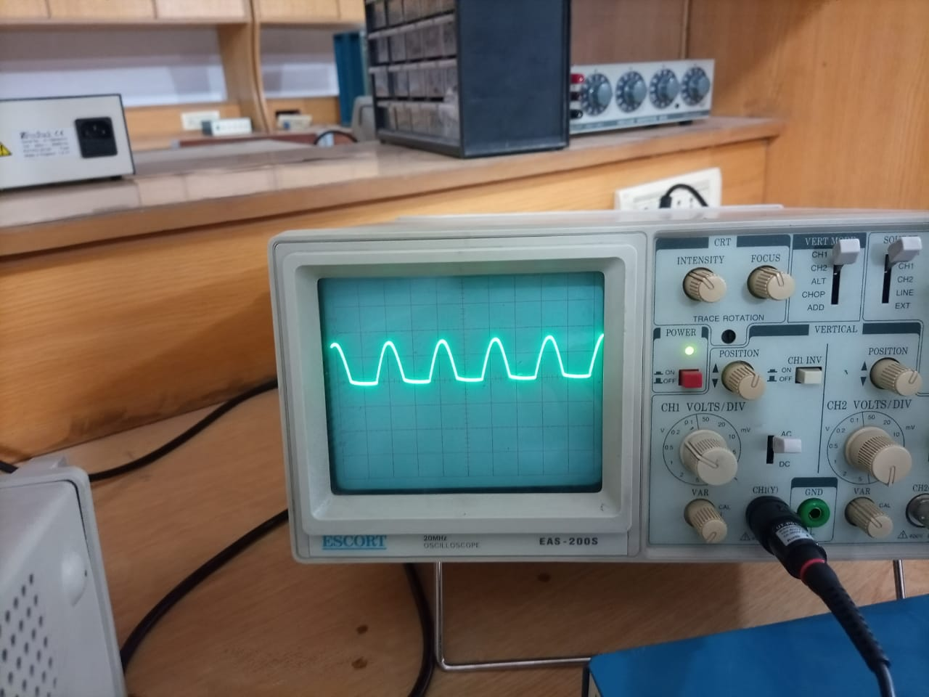

**Biased Negative Clipper:**

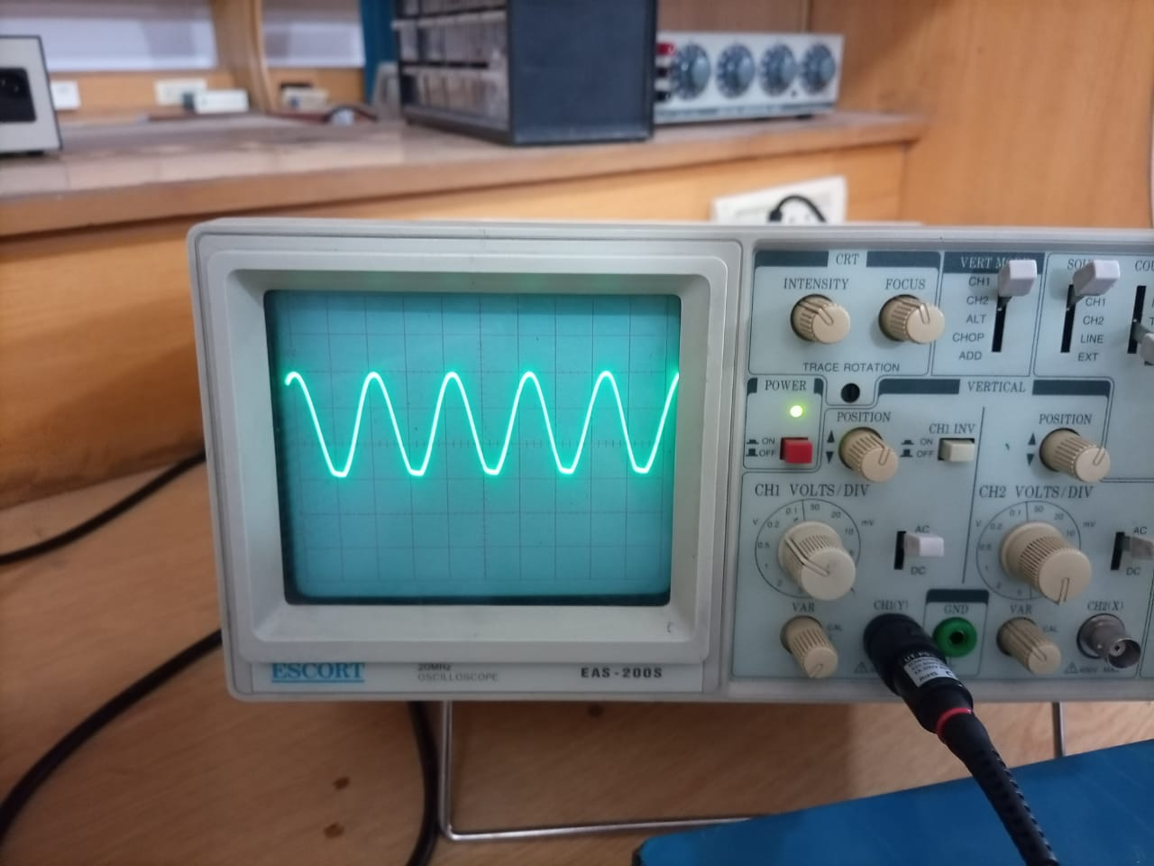

**Conclusion:**

* Positive series clipper: During positive half of cycle input voltage is positive therefore diode is reversed biased and act as open circuit hence output is zero. During negative half input voltage is negative because the polarity of AC voltage source change, therefore diode is forward biased and act as a closed switch and hence all the input voltage drop appear across the resistor.
* Positive biased series clipper: here same procedure occur which occurs in Positive series clipper but in case of reverse bias we provided Alternative DC voltage source by which we can increase or decrease the clipping of positive half cycle.
* Negative series clipper: During positive half cycle of input voltage is positive therefore diode is forward biased and act as closed switch hence all the input voltage drop appear across the resistor. During negative half input voltage is negative because polarity changed due AC voltage source therefore diode is reversed biased and act as open circuit hence output is zero .
* Negative biased series clipper: here same procedure occurs which occur in negative series clipper but in case of reverse bias we provided Alternative DC voltage source by which we can increase or decrease the clipping of negative half cycle.

In this lab we calculated and measure the input and output voltages of Positive Parallel clipper circuits and Positive Parallel clipper circuits. Positive Series clipper circuits and Negative Series clipper circuits.

**------------------------------THE END------------------------------**